Good Neighbor House Community Health Center

MIS 799 Capstone Project Report

Alex Mathew

Master of Information Systems

Raj Soin College of Business Wright State University

# Executive Summary

The purpose of this report is to provide complete documentation for Good Neighbor House (GNH) system analysis, system design, and implementation plan. The main emphasis of system analysis is to understand the specific needs in order to develop two modules for dental and vision to the existing wright state HIEx system. The system analysis was following a traditional structural analysis method that mainly uses flowcharts and data flow diagrams to illustrate the new system. In addition, the capstone project suggests that system development should be done in an incremental approach; therefore, developing dental and vision modules independently and integrate it into the HIEX system. The detailed process analysis examined each process using a process diagram and looked for clues to inefficiency, redundancy, or opportunity for error. The system analysis recommends providing a customized HIEx system to GNH heath center by developing dental and vision module that is integrated to the existing HIEx system. The GNH system analysis study was based on the six goals defined by the Institute of Medicine for healthcare quality improvement: safety, effectiveness, efficiency, timely, patient centered and equitable healthcare. The main risk assume are difficulty in calculating the ROI, long payback period, cost and issues during the implementation, and problems related to data management.

The report also contains suggested guidelines for HIEx implementation which are needed to be approved by board of directors before implementation.

Table of Contents

Executive Summary 2

I. The Problem 4

II. State-of-the-art review 10

III. Alternatives and Analysis 12

Analysis of the Current System 14

System Analysis Approach 14

System Development Life Cycle 24

System Requirements and Constrains 25

Functional Requirements 26

Non-Functional Requirements 27

Success Criteria 28

Constraints 28

Risks 28

Communication Plan 28

Work Breakdown structure 29

Roles and Responsibilities Matrix 31

IV. Recommended Solution 31

V. HIEx Implementation Plan 33

Roles and Responsibilities 34

Implementation Checklist and Technical Assessment 35

Operational Requirements 36

HIEx Implementation Phases 36

VI. Discussion of Benefits 37

VII. Reflection 38

References 40

APPENDICES 42

Appendix A: GNH Medical History Form 42

Appendix B: GNH Medical History Form 43

Appendix C: GNH Sliding Fee for Service Scale 44

Appendix D: Patient Treatment Plan 45

Appendix E: Patient Treatment Plan 46

Appendix F: Dental Sliding Fee Discount Application 47

Appendix G: Dental Sliding Fee Discount Application 48

Appendix H: Health Link Information Exchange (HIEx) User Manual 49

# I. The Problem

Good Neighbor House community health center is a charitable organization that provides medical services to low-income families. It is located in downtown Dayton, Ohio. The main revenue of GNH is the donation from individuals, charitable societies, and churches. The key competing industries are similar charitable societies located in Miami valley area, which are sharing the same resources for instance donation amount and public support. The strengths of GNH is that it has more than 270 active volunteers, financial support from eight churches, a dozen of experienced directors with vast areas, a group of volunteer physicians and other healthcare workers.

The main operation of GNH is providing medical care to the disadvantaged individuals. The clinical manager is responsible for all clinical tasks and managing the clinical department with the help of different clinical staff. The accounting department has two employees and the patient record department has one employee. As far as the census, last year GNH had around 1600 patient visits, which include 711 medical exams, 802 dental exams, and 72 optical cares.

The GNH staff has very limited use of hardware and software in the organization. The GNH have only four personal computers that are connected to the local router with a limited use of the Internet. The staff uses software only for office administrative tasks such as Microsoft excel for registration and Microsoft word for documentation and power point for presentation. GNH still using paper chart for patient heath records however, government mandates and other industry trends force us to adapt electronic heath records. On the other hand, the GNH needs huge investment and work force redesign. The main benefit of having EHR in healthcare in the future is that it reduces the cost of healthcare and provides services to large area of population. The main motivation for EHR is Health Information Technology for Economic and Clinical Health (HITECH) Act, which is a part of the American Recovery and Reinvestment Act of 2009. The Act encourages healthcare providers to use electronic heath records. By this act, government provides huge incentives to the healthcare providers who adapt electronic heath records and after 2015. The government will cut a percentage of payments from Medicare bills for those health providers who are not using EHR. The downside is that, at GNH most of the doctors and nurse practitioners work voluntarily, mandatory use of EHR may force them to leave the organization. There are many internal adjustments needed to happen in GNH so that the EHR implementation can be successful. Mainly, the workflow must change for the EHR system as well as the cultural change we need in clinical workforce. The employees need proper training that can help them to gain IT skills. We need to retrain some non-clinical staff in order to transform them to heath information technicians. Also we need to give some IT responsibilities to the clinical manger. In addition, we need to change the way emergency patients are admitted by providing online scheduling for patients. In addition, reducing the number of employees in the front desk may be of benefit in order to cut the expenses in the presence of online scheduling.

The most recent trend in healthcare is shifting the patient records from paper to electronic heath records (EHR). The main benefit of having EHR in the healthcare in future is that it reduces the cost of healthcare and provides services to large area of population. The main motivation for the megatrend is the Health Information Technology for Economic and Clinical Health (HITECH) Act is a part of the American Recovery and Reinvestment Act of 2009 encourages healthcare providers to use electronic heath records. By this act, government provides huge incentives to the healthcare providers who adapt electronic heath records and after 2015 government will cut a percentage of payments from Medicare bills in those health providers who are not using EHR.

The major impacts regarding to the trend are daily evolving and the health providers are coming with new technologies. Several patient surveys showed that main reason for the patient dissatisfaction while in the hospital was the long wait time in the emergency room. Large amount of healthcare work force such as doctors and nurses are trying to resist the changes because of lack of IT skills, fear to change, concern over patient safety, and alike. Implementing EHR needs to have a large amount of investment that small clinical groups cannot afford and that often pressurizes them to join big networks. Most of the healthcare work force has lack of IT skills so needs training in IT. Now organization has huge pressure to adapting to the new technology as early as possible to ensure the security of the patient heath records. Good Neighbor House (GNH) community health center is a small charitable organization that provides medical services to low-income families. Government mandates and other industry mega trend force GNH to adapt an electronic heath record which needs huge investment and work force redesign. In GNH most of the doctors and nurse practitioners work voluntarily, mandatory use of EHR may be force them to leave the organization.

The GHN considers replacing current system with reengineered business processes that help reduce the time for the availability of external lab report and make sure lab report seen by a doctor before goes to EHR. Also, GNH need to reduce the document delivery time as well as the cost for the postal service for the external lab reports. So after the EHR implementation, all lab report comes from externally must directly be scanned to the EHR system. The non-routine tasks are yearly and quarterly reports and making budgets and monthly meeting of directors. The other main routine task in the GNH is the lab work. The patients use two ways to do lab work: either internally or externally. Current business process for all the processed lab works are that all reports first goes to office sectary’s table and she sends it to the doctor and make sure the doctor reviews it before it goes to patient records has signed it. GNH need to reduce the document delivery time as well as cost for the postal service for the external lab reports.

The main activity at GNH is patient care. Now using the EHR, we can produce better outcomes. Due to the financial constrains management suggest outsourcing all the information technology activities such as electronic heath records, hardware maintenance, and website management. With limited IT knowledge, GNH staff would prefer a web based EHR with proper server backup and secure connection to the vendor location. The main concerns for implementing EHR in GNH are security concerns regarding the patient records as well as data flow interoperability between the systems in different healthcare providers. GNH assigned three different vendors, one for web based EHR, one for website hosting, and one for hardware, with help to reduce the possibility of security attack to the website that would affect EHR. Management decided domestic outsourcing because it is in the same time zone with GHN. GNH needs more control because of the HIPPA regulations, which also make it difficult to manage an offshore outsourcing. GNH prefers a subscription based EHR in order for GNH to attain a proper sourcing that has the lowest possible initiation price for the first year.

The project team use failure mode, effects analysis, risk model, and decision matrix tools to find the different risks and areas to outsourcing. The main risks in the initiating stage for GNH are cultural and political risks that depend upon the changes of governmental regulations and guidelines. The main risks for the contracting stage are financial and technological risks because outsourcing contact must specify the cost for technological advancement in the future. The main risks for GNH in the managing stage are political and technical changes that need to be addressed in the contract.

The GNH management mitigates risks in the managing stage by defining clear Service Level Agreements in contract. GNH created a governance group to monitor all activities related to development of EHR and establish a communication plan for project team and GNH staff. GNH also assessed the vendor’s security capabilities and security certification before outsourcing, all of which helped GNH to avoid security risks and legal risks related to HIPPA. Before signing the contract, GNH management evaluated vendor to assess the vendor’s capability by considering factors such as credit, financial stability, credibility, and previous projects.

The goal of this capstone project was to develop a web based EHR system for GNH that meets healthcare standards based on the HIPPA rules and HITECH Act. The new system needs to be developed in the basis of “Meaningful use of healthcare” such as complete and accurate information, better access to information, and patient empowerment. The system must follow the semantic interoperability, which helps to transfer patient data between providers without any technical obstacles. The system shall track patient information such as name, address, phone numbers, email address, and social security numbers. Every user will need a user ID and password to access the system and user roles will be set up in the system. The contract is a fixed-price contract, which includes development cost and service for the next ten years.

The success of the project was measured using three metrics, which are quality related metrics, financial metrics, and responsiveness related metrics. The main quality related metrics are basic standards for EHR. For example, new systems need to be tested and certified in accordance with the certification program established by the National Coordinator as having met all applicable certification criteria. In addition, it needs semantic interoperability; which will help transfer patient data between providers without any technical obstacles. GNH is a charity organization so the goal of financial metrics is to develop a system in a minimal time and cost and have a low cost maintenance. The responsiveness related metrics are essential for GNH as a health care organization; GNH need a vendor with high response rate and 24*7 supports.

The project will include several service levels (SL) metrics that are expected from the project team, namely, time, cost, capacity, security, privacy, and empathy.

**Time**

GNH need a time line for design: to develop and implement the system within 6 months. The project team allocates the first two months for design the system and the next two months to develop and last two months for implementation of the system.

**Cost per Module**

The system need to developing into three modules such as medical, dental and vision; so the vendor will receive cost per module divided by the total cost of the project.

**Capacity and flexibility**

When multiple users access and change data simultaneously it often corrupts data. Data corruption does occur in a multi-user access environment. To avoid data corruption or resource contention, the new system need to be a multi-tier authentication and authorization that can handle minimum ten users at a time.

**Auditing**

The new system needs to have time stamps and log tables to assure audit functions. The system need to be fully customizable therefore providing role-based access for each data element.  The audit records must include information about the operation that was audited, the name of the user performing the operation, and the date and time of the operation.

**Security and privacy**

As a healthcare provider, security and privacy are two very important things GNH need to consider before implementing EHR. The vendor need to follow all security and privacy rules related to HIPAA.

**Empathy and ambience**

The vendor’s onsite staff needs to be empathetical to the GNH’s patient’s health conditions and GNH staff’s needs due to their work pressures and lack of IT skills. As a heath care organization, GNH main goals are that our system needs to follow all guidelines and regulations from the government. With the limited amount of staff, GNH cannot monitor the vendor every time but GNH will consider the rating agencies rate of the product so the vendor need to be responsible for audit and maintain criteria’s from the rating agencies. The variations for the rating are a six months grace period but no deviations or tolerance levels for governmental regulations. The vendor should submit reports about rating every six months .As a healthcare provider GNH will sue the provider in the event of irresponsible behaviors that harm the human life. The main benchmarks are to double theproductivity of the staff, cut the service time to half, and reduce the cost for paper charts by 40%.

# II. State-of-the-art review

In the last 30 years, heath care is in a path of big transformation from paper chart to computer-based patient records then to electronic health records. The major difference between computer-based patient record and EHR is that, computer-based patient records are scanned images of paper documents, where as electronic heath record is data that are saved in a database. According to National Alliance for Health Information Technology, a certified electronic health record has interoperability standards for transferring data from one organization to another. The main benefit of capturing data electronically is that, stored in a database it can analyze and be used to generate reminders and other decision support tools to clinicians to further enhance the potential of EHRs to promote quality and reduce costs (Sheng & Berry, 2010). The recent trend of EHR is that its integrated system has the ability to provide service to the needs of both clinical and administrative users.

This integrated system will reduce fraud in healthcare which was reported by group of experts a contracted by ONC in 2005 to study about healthcare fraud related to information technology (The Office of the National Coordinator, U.S. Department of Health and HumanServices, 2005). The report also mentions that the fraud will eventually increase with large penetration of electronic heath records without a specific measurement to combat the threat. In addition, the report also recommends healthcare providers to implement electronic heath record standards with specific requirements for fraud management, which include limited opportunities for fraud and abuse. In 2006, another group of experts contracted by ONC came out with specific requirements for EHR to avoid fraud that largely emphasize the importance of audit capability for access to clinical information (The office of National Coordinator for Health Information Technology U.S. Department of Health and Human Services, 2007). The healthcare providers and other heath related organizations need to implement only EHRs with good quality, cost saving and fraud management even it delays adoption of electronic health records. The Institute of Medicine promotes EHRs with clinician decision support tools and computerized provider order entry as it is more accessible and legible information that will increase the quality of the healthcare ([Chassin &](http://www.ncbi.nlm.nih.gov/pubmed?term=Chassin%20MR%5BAuthor%5D&cauthor=true&cauthor_uid=9749483) [Galvin](http://www.ncbi.nlm.nih.gov/pubmed?term=Galvin%20RW%5BAuthor%5D&cauthor=true&cauthor_uid=9749483) 1998; Dick, Steen, & Detmer, 1997; Institute of Medicine, 2001; Kohn, Corrigan, & Donaldson, 1999). The goal of Institute of Medicine is to improve safety in healthcare by including EHR system that designed to make it “easy to do the right thing.” (Kohn, Corrigan., & Donaldson, 1999). Health care costs are reduced byreducing adverse drug events (ADEs); which is proven to be one of the main reasons for increased costs in healthcare. Effective use of EHR will detect and prevent ADEs and eventually reduce health care costs (Agency for Healthcare Research and Quality, 2001).

Healthcare providers also considers several other factors before implementing EHR such astarget area of care, how much control each users have to accessing patient information, layout for showing reports based on needs etc. The clinical decision support tools are primarily for alerting clinicians by analyzing patient information with clinical guidelines and to avoid medical errors. Before setting alerts, the implementation team must consider several factors: timing of the alert, speed and ease of access, clinician’s authority for making decision based on experience, and control users to respond alert (Berner, 2009).

Several researches show that EHRs that fit into the workflow have high success rates; which requires customization to the local processes and processes changes. So, it is very important to engage the clinicians in the planning of EHR implementation (Berg, 1997). The main goal of the adoption of EHR is that clinicians will get information for advance health which helps them to provide the best care, at the right time, every time to the patients. So workflow must be designed to supported clinician and staff in every level that will increases the quality of care, patient satisfaction, employee productivity, and job satisfaction (Garrity, 2010).

# III. Alternatives and Analysis

The HIEx system was originally designed as a registry for medically uninsured using the web portal model and protected by a virtual private network. HIEx Application is developed in VB.net as front end and Microsoft SQL database as backend. The system has developed under the guidelines of ICD-9 and SNOMED CT. The HIEx system currently uses several sites in Dayton. The servers are located in very secure places and managed by Wright State University research department. The system was designed in compliance with HIPAA privacy and security rules and unified medical language system.

The current system supports source and time stamps and log tables to assure audit functions. The main goal of auditing is to monitor and record specific database activities such as unauthorized accesses or altered, including content. The auditing enables future accountability for current actions taken in a particular schema, table, or row, or affecting specific content and investigate suspicious activity.  Audit records include information about the operation that was audited, the name of the user performing the operation, and the date and time of the operation. Audit records can be stored in a data dictionary table which contains the information events audited such as user name, instance number, operation performed or attempted, date and time, system privileges used etc. The recording of audit information is enabled or disabled only by the security administrator.

To avoid data corruption or resource contention, the HIEx application provides multi-tier authentication and authorization. The HIEx system   has a capacity to connect 1,500 concurrent connections. The application controls the security of middle-tier applications by limiting their privileges and connection pooling, which allows multiple users to access a data server without each of them needing a separate connection which set up and break down connections very quickly.

## Analysis of the Current System

When looking at the technological readiness, the GNH staff has very limited use of hardware and software in the organization. The GNH have only four personal computers that are connected to the local router with a limited use of internet. The staff uses software only for office administrative tasks such as Microsoft excel for registration and Microsoft word for documentation and power point for presentation. The project team conducted several interviews and facilitated group meetings with the GNH staffs which helped to understand functional and nonfunctional requirements. The project team collected different models of paper chart that are used in GNH to identify the essential data fields. They are medical history form, GNH fee for service scale, patient tracking reports, dental fee discount application, and patient treatment plan. Appendices A to F show some examples of such forms.

## System Analysis Approach

The project team used structural system analysis processes centered method to analyze the flow of data through business and software processes. The project team used three tools to model the processes: flowcharts, data flow diagram, and business processes diagrams. The models show the flow of data between HIEx system and HIEx database and its relationship between different entities. The models also show the proposed redesigned processes with different patient data flow and situations with different inputs. The project team started with less detailed approach with process inventory and process diagrams with a context diagram and flow charts. The context diagram shows basic clinic functions (Figure 1) and flowcharts show the medical (Figure 2), dental (Figure 3) and vision (Figure 4) processes. The business process flow charts (Figure 5) shows proposed new work flow in the GNH. The level 1 data flow diagram shows the all process in the GNH and level 2 data flow shows different level of data flow in the GNH.

Figure 1 shows the context diagram for the new system and how it works for different clinic functions as an interface between patient and HIEx database. The registration process matches the database with patient data which helps to avoid duplication from the double entry. The other main process are vital signs entered by the medical staff and discount from the database based on the income of the patient.

**Figure 1: Context Diagram**

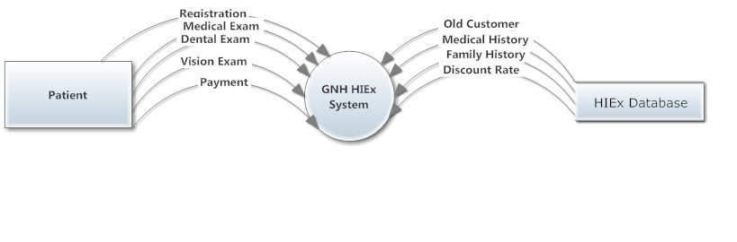

Figure 2 shows the detailed flow of the medical services in GNH. The process starts with patient arriving to the location then new patients’ needs to fill all paper paperwork then process proceeds to eligibility check processes which is based on the income then medical examination and processes ends with when patient leave.

**Figure 2: Medical Flow chart**

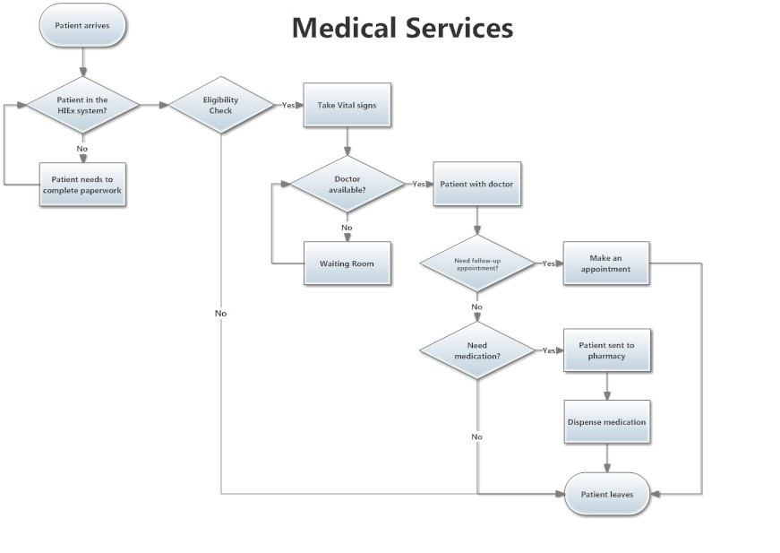

Figure 3 shows the workflow for the dental services that are very similar to medical examination but different payment options. The dental process starts when patient visit starts and ends when patient leave. First, system checks the patient unique details with the system and classify patient as a new an old client. New patients need to complete all paperwork before the eligibility check processes but the prior patients can directly go to eligibility check processes without doing paperwork. Eligibility check mainly compares the patient’s income with government poverty level and decides eligibility for using the dental service.

**Figure 3: Dental Flow Chart**

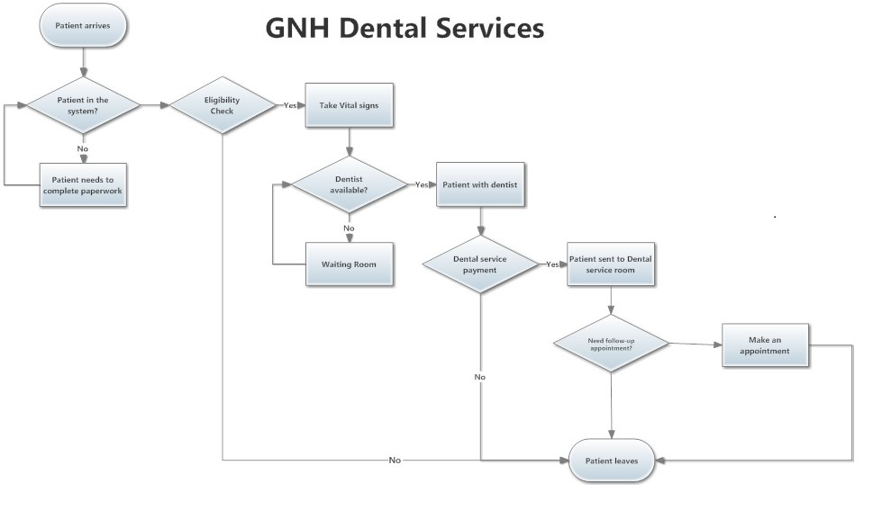

Figure 4 shows the workflow of the vision services that are very similar to medical examination. The vision process also starts when patient visit start and ends when patient leaves. First, system checks the patient unique details with system and categorizes the patient as new or old. New patient need to complete all paperwork before the eligibility check processes but prior patients can directly go to eligibility check processes without doing paperwork. Eligibility check mainly compares the patient income with government poverty level and decides eligibility for using the vision service.

**Figure 4: Vision Flow chart**

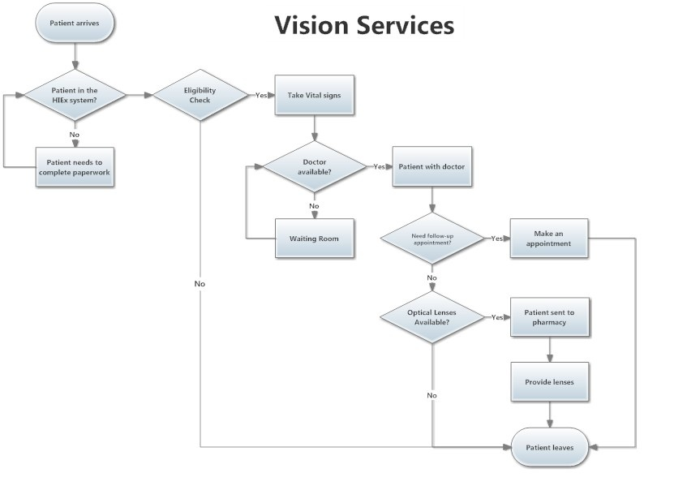

Figure 5 shows the business processes in the GNH and it starts with patient visit and ends when patient leaves. The diagram also shows the owner of each process in GNH. The processes owners are patients, doctors, administrative staff, and clinical mangers. The clinical manger is the process champion as she is the responsible party for all activities in GNH. There are two types of functional groups in BPM team and they are clinical and nonclinical groups. The main objective of BPM activity in GNH is to replace paper patient chart into electronic heath records.

**Figure 5: GNH Business Processes**

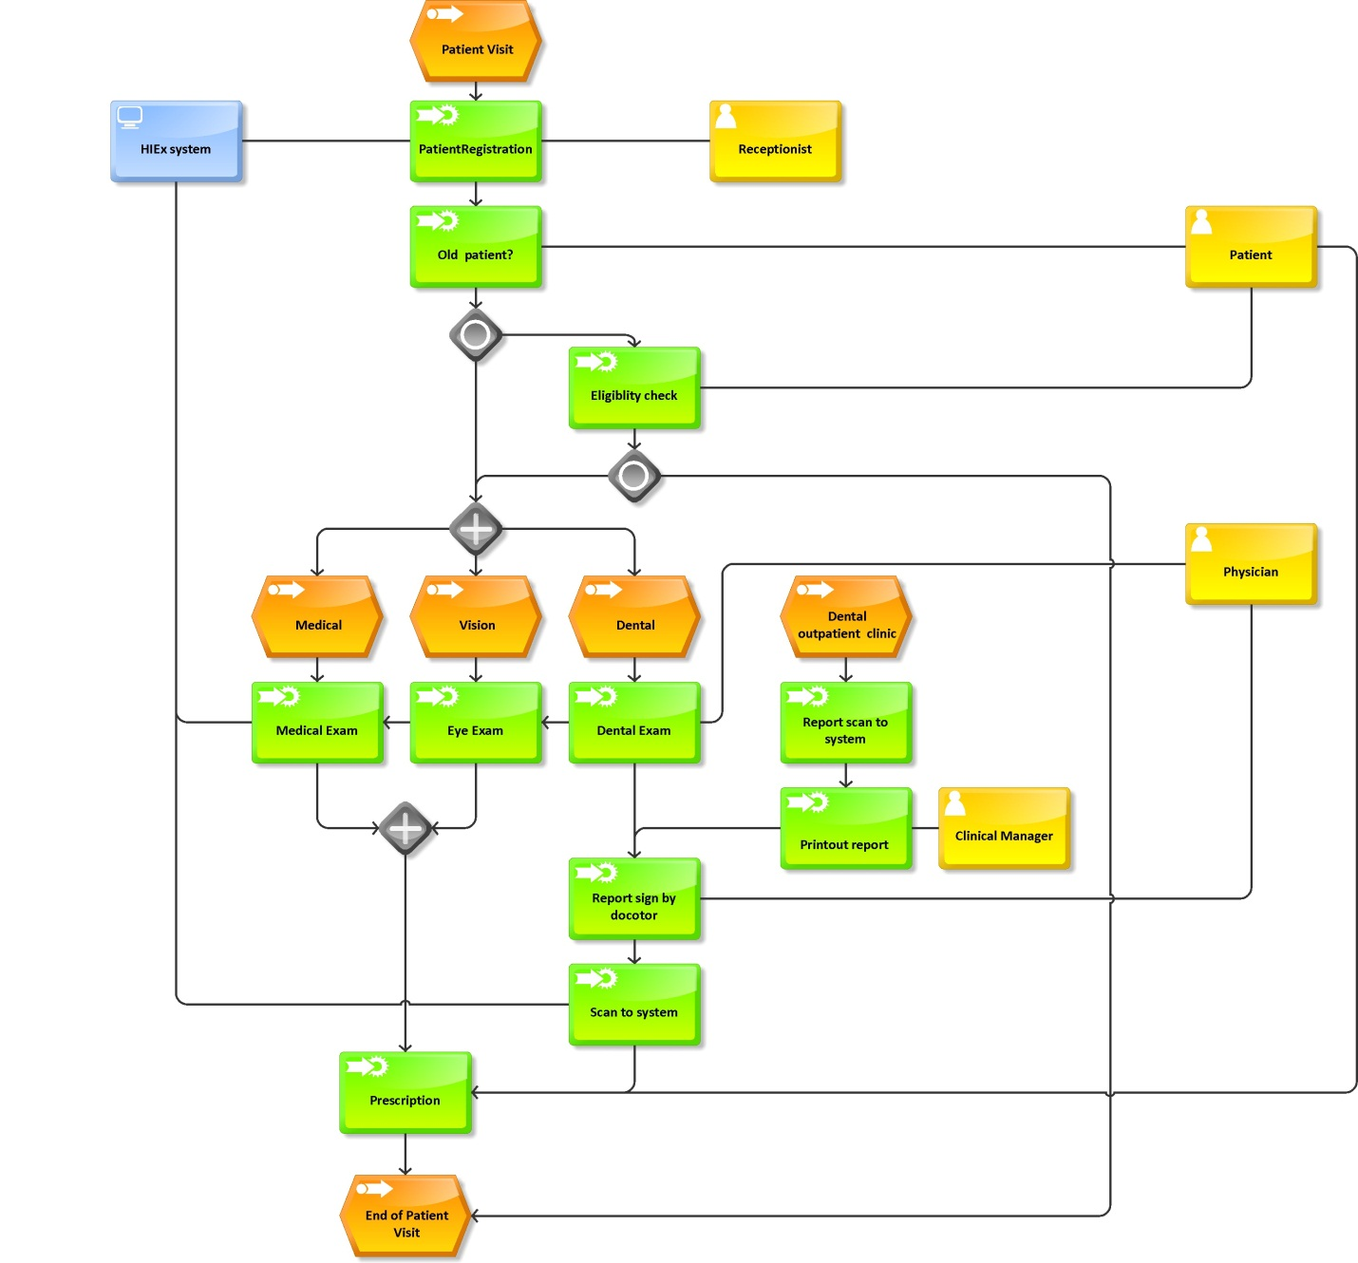

Figure 6 shows the level 1 data flow diagram that represents different dataflow between the HIEx database and system. The DFD fragments follow the pattern of input-process-output. The level one GNH DFD contains six processes they are registration, medical exam, dental exam, vision exam, billing, and payment. During the registration process, the patient demographics and annual income will enter in the HIEx database and it checks eligibility for the service based on income in comparison to the poverty level. The main activities in medical, dental and vision are entering vital signs into the system. During the billing process the patient bill is based on the GNH sliding fee for service scale (Appendix C).

**Figure 6: Level 1 GNH Data Flow Diagram** 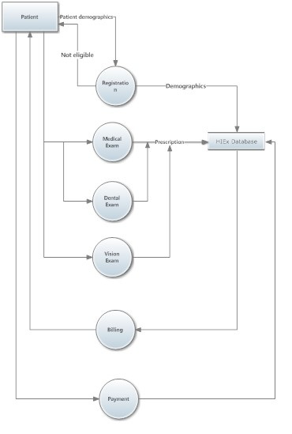

Figure 7 shows the level 2 Registration Data Flow Diagram. The main activities in the registration DFD are patient registration, eligibility check, and entering vital signs of patient. The eligibility is based on the number of members in household and annual income.

**Figure 7: Level 2 Registration Data Flow Diagram**

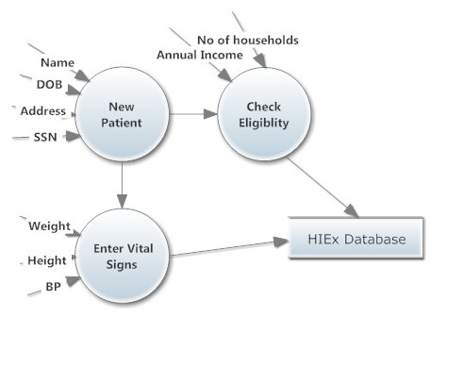

Figure 8 shows the level 2 medical DFD diagram .The main activities in the medical DFD diagram are patient search form ,treatment plan and doctor notes. The name and patient ID number is used in the patient search form to identify the patient.

**Figure 8: Level 2 Medical Data Flow Diagram**

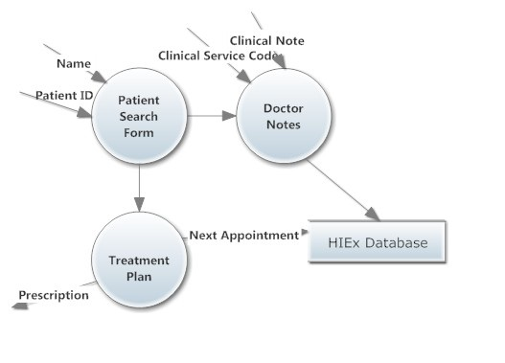

Figure 9 shows the level 2 dental data flow diagram. The main activities in the dental DFD diagram are patient search form, dental treatment plan and dentist notes. The name and patient ID number is used in the patient search form to identify the patient.

**Figure 9: Level 2 Dental Data Flow Diagram**

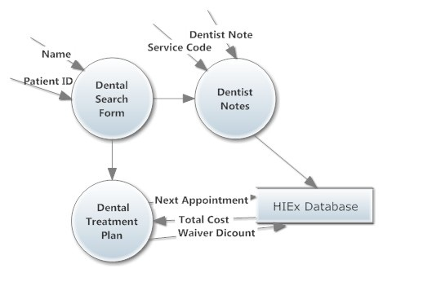

The Figure10 shows level 2 vision data flow diagram. The vision DFD is very similar to the level2 medical DFD. The main activities in the vision DFD diagram are patient search form, vision treatment plan and doctor notes. The name and patient ID number is used in the patient search form to identify the patient.

**Figure 10: Level 2 Vision Data Flow Diagram**

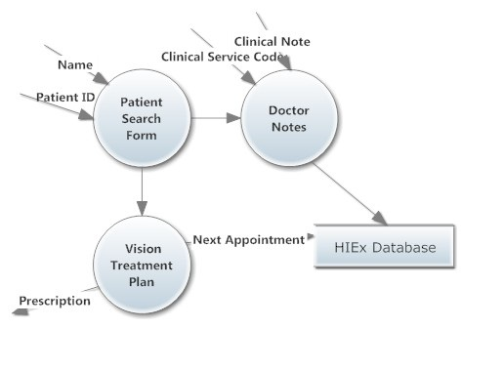

## System Development Life Cycle

The system development will follow incremental approach; we will develop dental and vision modules (Figure11) separately; and integrate it into the existing HIEx system. After developing each module, both modules will be made available to the GNH staff for testing and fixing the issues before integrating it into the GNH system. This approach will increase the communication between the project team and GNH staff; which will help to identify the missing requirements and identify the potential issues before system implementation.

**Figure 11: GNG System Development Life Cycle**

HIEx

System

Initiation

Dental

Module

Test

Dental

Module

Design

Dental

Module

Analysis

Vision

Module

Analysis

Vision

Module

Design

Vision

Module

Test

System Implementation

## System Requirements and Constrains

System requirements will be to develop a standardized format of health-related data for transferring among organizations according to nationally recognized standards. The system need to interoperable to other qualified EHRs for the meaningful use of HIT incentives. HIEx Dental and vision modules meet the requirements included in the definition of a qualified EHR. The system need to be tested and certified in accordance with the certification program established by the National Coordinator as having met all applicable certification criteria. System needs to support intellectual, physical, and sensory requirements for the staff, clinical manger, and doctors that contribute to the total system performance. System needs to be entirely customizable role based access for each data element. System need to support source, time stamps, and log tables to assure audit functions.

### Functional Requirements

* The HIEx system need to be in customize to identify needs so that the system can support the users goals
* The system must be follow healthcare standards based on the HIPPA rules and HITECH Act
* System need to be developed in the basis of “Meaningful use of healthcare” such as complete and accurate information, better access to information, and patient empowerment.
* System must follow the semantic interoperability which helps to transfer patient data between providers without any technical obstacles.
* The system shall track patient information such as name, address, phone number, email address, and social security number
* Develop and integrate a vision module which contains patients prescription details and can be retrieved from reports
* Develop a GUI interface for teeth number notes for dental module and it will be saved to reports.
* Dental module must include income field which is linked to an algorithm for calculating the service fee depending upon the annual income
* Reports can be printed or displayed online
* Maintain history of user logs for audit purposes
* Automatic alerts to physicians about disease based on family history
* Develop a vision module which includes vision codes available to the clinician so that clinicians can foresee the cost and other details. Develop a prescription report tab in the system; so that the follow up appointments can have a better flow as other providers/staff members are aware of what the previous recommendations/prescriptions were.
* Develop a dental module which incorporates the already existing dental codes in to the system so that it automatically calculates the cost with discount based on income using the codes. The dental module needs a graphical interface that helps the dentist to mark and write notes on the teeth need to treat and automatically that notes are made available in the dentist report.

### Non-Functional Requirements

* HIEx system shall be secure from inside and outside the GNH.
* User will need a user ID and password for access to the HIEx system
* User roles will be set up in the system
* System will be developed in a minimal time and cost
* System will have a low cost maintenance
* System tabs and interfaces need to be similar to Web2.0 Technologies which increases the usability.
* GNH needs new workflow for external lab reports for the dental module

### Success Criteria

Implement HIEx system in at Good Neighbor House Community Health Center .Design, develop, test and implement the system within 6 months. Improve productivity of office staffs, physicians, and volunteers .Reduce the cost for paper charts by 40%

### Constraints

1. Stay within stated time
2. Government regulations
3. Technical problems due to new version of .Net software

### Risks

1. Privacy concerns
2. HIPPA regulations
3. Employee resistance

## Communication Plan

The project team recognizes that successful completion of project needs good communication between stakeholders and project team. The development team decides to meet every Tuesday for reporting the status of the project. The project team meets with GNH staffs once in a month and updates the project status and shows the system. Share the phone numbers and email address of GNH staffs and development team for better communication .Communication plan contains internal kickoff meeting and external meeting with GNH staff. The communication plan includes an internal project management Gantt chart, external project management Gantt chart and Redmine website for reporting and tracking issues.

The project team used the existing HIEx system as a prototype in the first meeting with the GNH staff and took feedback from them .During the second meeting HIEx system need be presented with second prototype which includes dental and vision module.The project team needs to use exiting sites using HIEx system as test case scenario for GNH staff and plan location visit on those sites and demonstrate how the system works in those sites.

Develop a project support document to explain different fields in the HIEx system and technical details. Update existing VPN connecting manuals with new technical details.

Develop a maintenance plan that clearly states the rule of different stakeholders in the system maintenance and briefly describe the support concept for the system. Subscription fees will provide the necessary support for general maintenance and sustainability of the project.

### Work Breakdown structure

1.0 Project Start

1.1 Internal Kick-off Meeting

1.2 GNH Kick-off Meeting

2.0 Environments

2.1 Build development

2.2 Develop PM (Redmine)

2.3 Build Test

2.4 Build Production

3.0 Requirements

3.1 Dental Module

3.1.1 Identify missing &Reusable elements

3.1.2 Eligibility Algorithm

3.1.3 Reporting

3.2 Vision Module

3.2.1 Identify missing &Reusable elements

3.2.2 Eligibility Algorithm

3.2.3 Reporting

4.0 Design, Develop and Unit Test

4.1 Dental Module

4.1.1 Module design

4.1.2 Module coding

4.1.3 Module Test

4.2 Vision Module

4.2.1 Module design

4.2.2 Module coding

4.2.3 Module Test

5.0 Integration (system) Testing

5.1 Dental Module

5.2 Vision Module

6.0 Updates

6.1 Test

6.2 Fix Issues

6.3 Complete Testing

7.0 Deploy System

### Roles and Responsibilities Matrix

|  |  |  |  |  |
| --- | --- | --- | --- | --- |
| Responsible Party | | | | |
| Activity | Cauley | Ralph | Salam | Alex |
| 1.1 | A | R | I | I |
| 1.2 | R | I | I | I |
| 2.1 | A | R | R | R |
| 2.2 | C | R | I | I |
| 2.3 | I | C | R | R |
| 2.4 | I | C | R | R |
| 3.1 | I | I | R | R |
| 3.2 | I | I | R | R |
| 4.1 | I | I | R | R |
| 4.2 | I | I | R | R |
| 5.1 | I | I | R | R |
| 5.2 | I | I | R | R |
| 6.1 | I | R | R | R |
| 6.2 | I | C | R | R |
| 6.3 | I | R | R | R |

# IV. Recommended Solution

There are many internal adjustments needed to happen at GNH in order for this organization to be successful after the EHR implementation. Mainly, the workflow must change for the EHR system as well as there is a cultural change we need in clinical workforce. The employees need proper training to help them gain IT skills. We need to retrain some non-clinical staff in order to transform them to heath information technicians. Also we need to give some IT responsibilities to the clinical manger. In addition, we need to change the way emergency patients are admitted by providing online scheduling for patients. Further, reducing the number of employees in the front desk may be of benefit in order to cut the expenses in the presence of online scheduling.

There needs to be a process change in order to assure that all lab results are reviewed by the physician. Due to the lack of funding, current EHR implementation plan cannot have PACS system so the employees need to manually scan the lab reports and store it in the EHR. So the problem is that every lab report must be seen and signed by a doctor before its goes to report. The GNH patients use two ways to do lab work: internally and externally. Current business processes happens by making sure all reports first goes to office sectary table and then send to the physician’s desk to make sure it has been signed by the doctor before its goes to patient records. So, we need a change in business processes that helps to reduce the time for the availability of external lab report and make sure it’s seen by a doctor before goes to EHR. Also we need to reduce the document delivery time as well as cost for the postal service for the external lab reports. So after the EHR implementation, all lab report coming from externally must be directly scanned to the EHR system and need a redesign in the business processes.

To access the system, a user must use a login page and attempt a connection with a valid user name and password. The system needs to provide easy and controlled privilege based on roles. The users have different accessing privileges based on the roles on the use of application. Each user must be granted a different set of privileges that allow for more or less data access while using the application. The system administrator must create a user role for a group of users with common privilege requirements.

The application will be locked on a user's account after a specified number of consecutive failed log-in attempts. The account will unlock automatically after a specified time interval .The administrator has the privilege to lock or unlock accounts manually. Every Password has a life-time for three months, after that it will expire and must be changed before account log-in is again permitted. A grace period of ten days is established, during which each attempt to login to the database account receives a warning message to change the password. If it is not changed by the end of that period, then the account is locked. Each user password must be a minimum of six characters in length. The user id and password must be different. The password must include at least one alphabet character, one numeric character, and one punctuation mark. The password must be different from the previous password by at least three characters.

# V. HIEx Implementation Plan

The main goal of the HIEx implementation plan is to provide information and guidance for the implementation of HIEx system in GNH. The document contains suggested guidelines for HIEx implementation which are needed to be approved by board of directors before implementation. The main risk factors for HIEx failure are poor communication, lack of involvement of key stake holders in the planning, lack of sustained top level support, and poor implementation planning. The key factors for successful HIEx implementations are established goals and benchmarks, excellent communication, project management, and thorough work flow analysis and implementation plan. The suggested implementation plan is a big bang implementation; but it will include phased prototype training.

The main advantages of suggested implementation is that it will avoid staff’s unfamiliarity and pressure in the implementation time, avoid after implementation training, and increase the ownership of the system by GNH staff .The main disadvantages of the current implementation plan are the long time duration for the implementation and increasing new demands from clients. The project team decided to share the system with staff before implementation which helps them to familiarize the system and it will help the implementation. Before the HIEx implementation, the GNH need to plan a scanning strategy for existing paper charts; simultaneously entering data into HIEX charts, in order to minimize GNH workload as much as possible during the implementation and a weeks after the implementation.

## Roles and Responsibilities

The clinical manger will be the project manager and will direct the HIEx implementation. The clinical manager will produce the HIEx implementation plan and will manage the implementation process in GNH. The clinical manager can use HIEx manual for training GNH staff and physicians before implementation. The clinical manger needs to develop an implementation timeline that will be presented to and approved by the management. The clinical manger will coordinate the implementation, training, and support the implementation processes in GNH in collaboration with the help of project team. The clinical manager needs to follow project management processes guide and direct implementation teams with necessary resources for implementation.

The HIEx system developer needs to work as the site implementation manager who is responsible for primary contacts at the site for all implementation activities. The site implementation manager’s responsibility is to collects information on implementation phase issues and concerns and report to the clinical coordinator. The site implementation manager needs to communicate effectively to all stakeholders and project staff. Site implementation manager also need to come with innovative solutions to implementation phase issues and mitigate risks.

## Implementation Checklist and Technical Assessment

The implementation team needs to develop an implementation checklist to evaluate the completion of necessary steps before implementation. The clinical manger is primarily the responsible person for maintaining the checklist with the help of implementation manger. The implementation checklist needs to be distributed to all staff minimum one week before the implementation date.

The implementation team also needs to conduct technical assessments for hardware, software and network. The hardware technical assessment mainly collect details about inventory of all computers, scanners, routers, switches, peripherals, and printers also this inventory would include type, location, memory, free storage space, year of made and condition. The software technical assessment would collect the details about the software list for each computer in GNH which includes operating systems, office software, spywares and anti-virus protection. The HIEx server is stays in the Wright State location and CaTS team is responsible for server maintenance, redundancy, security, emergency contingencies, and upgrades.

GNH needs to use a licensed version of windows operating system in all computers specifically Windows 2008 or above. GNH need to install Microsoft office 2010 version in all computers for generating reports from HIEx system. The implementation team also needs to conduct assessment fornetwork traffic between the HIEx server and GNH computers based on HIPAA regulations. The network assessment also needs to check the VPN connectivity, encryption algorithms, firewalls, gateways, and other security measures for the network packet security. The implementation team should produce a plan to avoid any potential damage in the instance of security violation. This plan needs to be approved from the implementation team and must be included in the implementation manual.

## Operational Requirements

* Operating Systems-Windows 2008 (recommended) or higher version
* Hardware Specifications
* Processors-Intel Pentium, AMD, or compatible; 1 GHz or faster
* Memory-512 MB RAM
* Data backup components is required

## HIEx Implementation Phases

Implementation scheduling is dependent upon several factors; they are site commitment, site resources, administration scheduling, staff training, financial resources, site readiness, and available IT resources. The project team recognizes that a GNH require a longer period of time to complete the implementation because of the management and administrative approval. Meanwhile the project teams will implement a prototype HIEx system for training purpose helps GNH staffs acquire knowledge and technical skill for the implementation. The issues, experiences and responses during the prototype must be documented and use for planning implementation.

The implementation phase is the phase formal implementation of HIEx system in the GNH with the approval of all governing bodies. The GNH staff and implementation team will use the knowledge gained and lessons learned during the prototype phase will use for the success of the implementation. The project team will train all the GNH staff to operate and maintain the HIEx system before the original implementation with help of training manual and prototype. After the completion of implementation phase project team will do a post implementation and closeout phase to acknowledge the efforts and the successful completion of implementation.

# VI. Discussion of Benefits

The main problem among EHR system is that the customers are forced to accept the lower usability systems because of the lack of user friendly system. Our system is very user friendly which is very similar to Web2.0 technologies; therefore, it increases usability among the customers. The HIEx system is the lowest cost EHR system in the market with no maintenance fee for the client. The HIEx system has income based service and family oriented services.

The HIEx system is able to capture chronic disease data based on the vital signs that will improve chronic patient care. The HIEx system will reduce medical errors during the patient care by checking drug interactions, allergies and drug compatibility. The HIEx will automate prescription writing in the GNH and improve record availability to staffs in the GNH.

The new system does not need any hardware because the HIEx is web-based EHR, GNH have very limited budget for hardware. The new system helps GNH to replace hand written paper charts with electronic charts which helps to avoid medical errors. The GNH can reduce the cost of paper chart by around 40% by implementing HIEx system.

The HIEx system helps to reduce GNH employee’s frustration due to paper chart; it will increase the productivity and contribution for the organizational output. The benefits may influence other similar organizations and change the culture of system. The new system will produce better customer service by mining the database with health information exchange. The system will help GNH to reduce unwanted manpower and increase data integrity .The system has cost saving by utilizing less money for security and infrastructure.

The point of view of top management is mixed between the benefits and the risks of the EHR. The main risk they assume are difficulty in calculating the ROI, long payback period, cost and issues during the implementation, and problems related to data management. According to some top management, the most important aspect of GNH is by improving GNH in comparison to EHR. For the better labor productivity, they might suggest more investment in employee training and human resource management. IT Function is likely to favor of the adoption of EHR. They counter the negative points such as long payback period and difficulty in calculating ROI with the competitive advantage and profits from reducing shrink and higher labor productivity.

# VII. Reflection

Overall I have an alarming feeling about healthcare industry as it is complex, complicated as well as bureaucratic. I have also had previous experience with learning an EHR system called VistA used by VA. I feel it’s very hard to learn from my experience handling systems like UNIX and other banking system. I realized the main obstacle for wide adaption of EHR implementation is employee resistance because of their lack of IT skills and also I feel something else missing in the picture which is contributing to the resistance. I also think EHR systems are complicated because it needs to follow many government guidelines and needs to be interoperable to data exchange.

I thought it’s hard to integrate the dental and vision module to existing HIEx system mainly because of two reasons one is that the old HIEx system was actually developed by someone who is not in the current development team that creates some technical difficulties to understand the system. Current HIEx system was developed in an old version of .Net software which creates some technical difficulties .For example, anytime someone navigate from one page to another, system will check with the master page for authentication; which in essence, makes the system slower and some pages are broken and have problems when system tries to update and modify.

This project helped me to understand the importance of usability of EHR systems in the healthcare industry. I learned a lot about the healthcare industry practices and how to work as a team. This project is a good practical experience for me to understand the proper way to do system analysis and design. My work experience is mostly system support and implementation for telecom vendors but I did not have not much knowledge about the how to develop a system. I can handle issues and needs during the implementation scenario but I didn’t know how to develop a system from zero. I had hard time doing system analysis in the past; however, now I know where I need to start. I understand that when implementing EHR, health care employees are looking for similar technologies that they are familiar with; so, usability is the first guru of learning. The interesting thing about this project is that, a group of clinical professionals with minimal IT skills and an IT project team with no healthcare experience when joined together created a wonderful electronic health record system.

I think the most memorable moment in this project is when I got appreciation from the project team for my solution for a big problem group during the client visit. “Tell me and I forget, teach me and I remember, engage me and I learn.” - Chinese Proverb. I think main reason for the success of this project is engagement and good communication. We had weekly meetings of staff help us to identify and resolve issues which was a great help to making a successful product. Training a sufficient number of super-users helped us to empower staff as problem solvers in GNH for simple user issues.

# References

Agency for Healthcare Research and Quality (2001). Reducing and Preventing Adverse Drug

Events to Decrease Hospital Costs. Rockville, MD; March 2001.

Berg, M. (1997). *Rationalizing medical work: decision-support techniques and medical practices*. Cambridge, MA: MIT Press.

Berner, E.S., (2009). Clinical Decision Support Systems: State of the Art. *Agency for Healthcare*

*Research and Quality*, June, 2009.

[Chassin, M.R](http://www.ncbi.nlm.nih.gov/pubmed?term=Chassin%20MR%5BAuthor%5D&cauthor=true&cauthor_uid=9749483). & [Galvin, R.W](http://www.ncbi.nlm.nih.gov/pubmed?term=Galvin%20RW%5BAuthor%5D&cauthor=true&cauthor_uid=9749483). (1998). The Urgent Need to Improve Health Care Quality.

Institute of Medicine National Roundtable on Health Care Quality. *JAMA* 1998 Sep 16; 280(11):1000-5.

Dick, R. S., Steen, E. B. & Detmer, D. E. (Eds.). (1997). Computer Based Patient Record: An

Essential Technology for Health care. Washington, DC: *National Institute of Medicine, National Academy Press.*

Garrity, W.F. (2010). Libraries and Electronic Health Records: Focus on “evidence” as Part of

Treatment and Care, not on “the library”. *Journal of Medical Library Association*, 2010 July; 98(3): 210–211.

Institute of Medicine (2001). Crossing the quality chasm: A New Health System for the 21st

Century. Washington, DC: National Academy Press; 2001.

Kohn, L., Corrigan, J.M., & Donaldson, M. (1999). To Err is Human: Building a Safer Health

System. Institute of Medicine, National Academy Press.

Sheng, Y., & Berry, D. (2010). Terminology Enhanced EHR: integration of

archetypes and terminology, an implementation experience.*TeaPOT Research Group,*

*Dublin Institute of Technology,* 2010.

The Office of the National Coordinator, U.S. Department of Health and Human

Services (2005). Use of Health Information Technology to Enhance and Expand Health Care Anti-Fraud Activities*. American Health Information Management Association, September, 2005.*

The office of National Coordinator for Health Information Technology U.S. Department of

Health and Human Services (2007).Recommended Requirements for Enhancing Data Quality in Electronic Health Record Systems. *Research Triangle Institute*, May, 2007.

[Webster](http://www.ncbi.nlm.nih.gov/sites/entrez?cmd=search&db=PubMed&term=%20Webster%2BPC%5bauth%5d), P. C., (2010). Electronic health records: an asset or a whole lot of hype?. *Canadian*

*Medical Association Journal,* 2010 March 9; 182(4): E193–E194.

# APPENDICES

## Appendix A: GNH Medical History Form

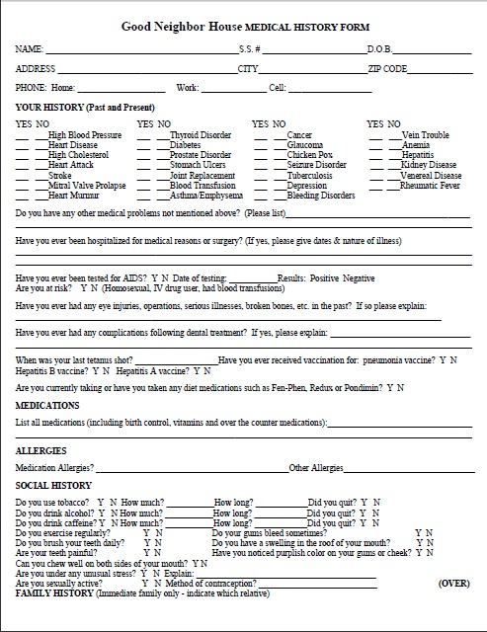

Exhibit A: GNH medical history form is used at the registration counter for collecting basic demographics of the patient. It consists of both demographics as well as the patient medical history including past and present medications, allergies, social history, and family history.

## Appendix B: GNH Medical History Form

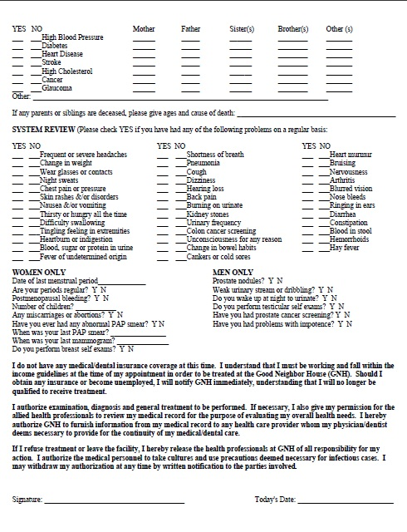

The Exhibit C is the second page of GNH medical history form that has a separate table for men and women which entails heath details and system review (current heath condition).

## Appendix C: GNH Sliding Fee for Service Scale

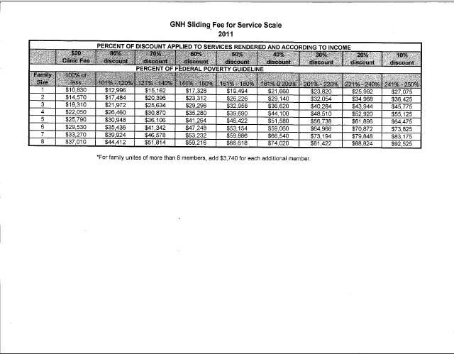

The Exhibit D shows the GNH Sliding fee for service scale. The table is mainly for calculating percent of discount for the medical services based on the annual income. The table also shows the clinic fee and the discount based on annual income and family size.

## Appendix D: Patient Treatment Plan

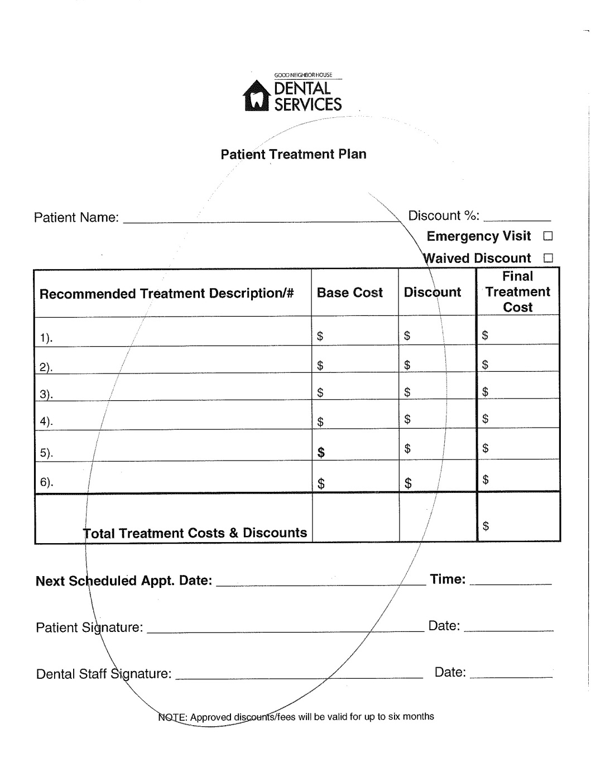

The Exhibit E is the dental treatment plan which contains patient name, next patient visit date, recommended treatment description, base cost, discount, final treatment cost, and total treatment cost. The patient treatment plan needs to be signed and dated by both patient and dental staff.

## Appendix E: Patient Treatment Plan

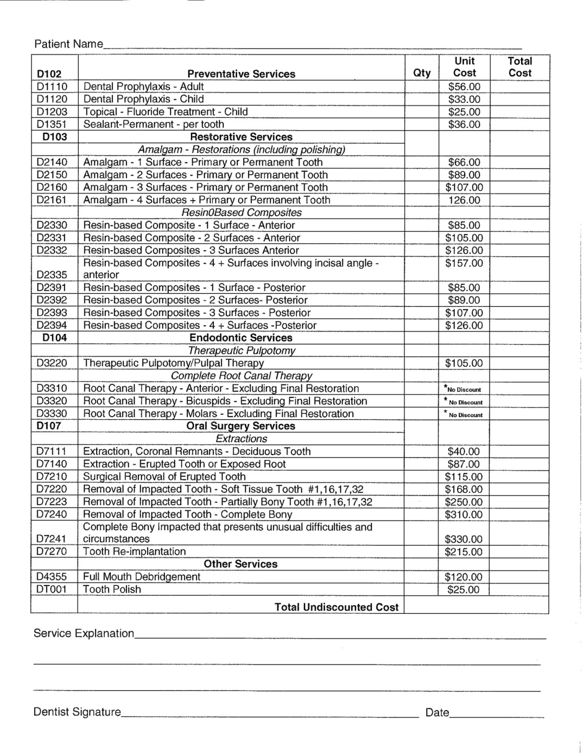

## Appendix F: Dental Sliding Fee Discount Application

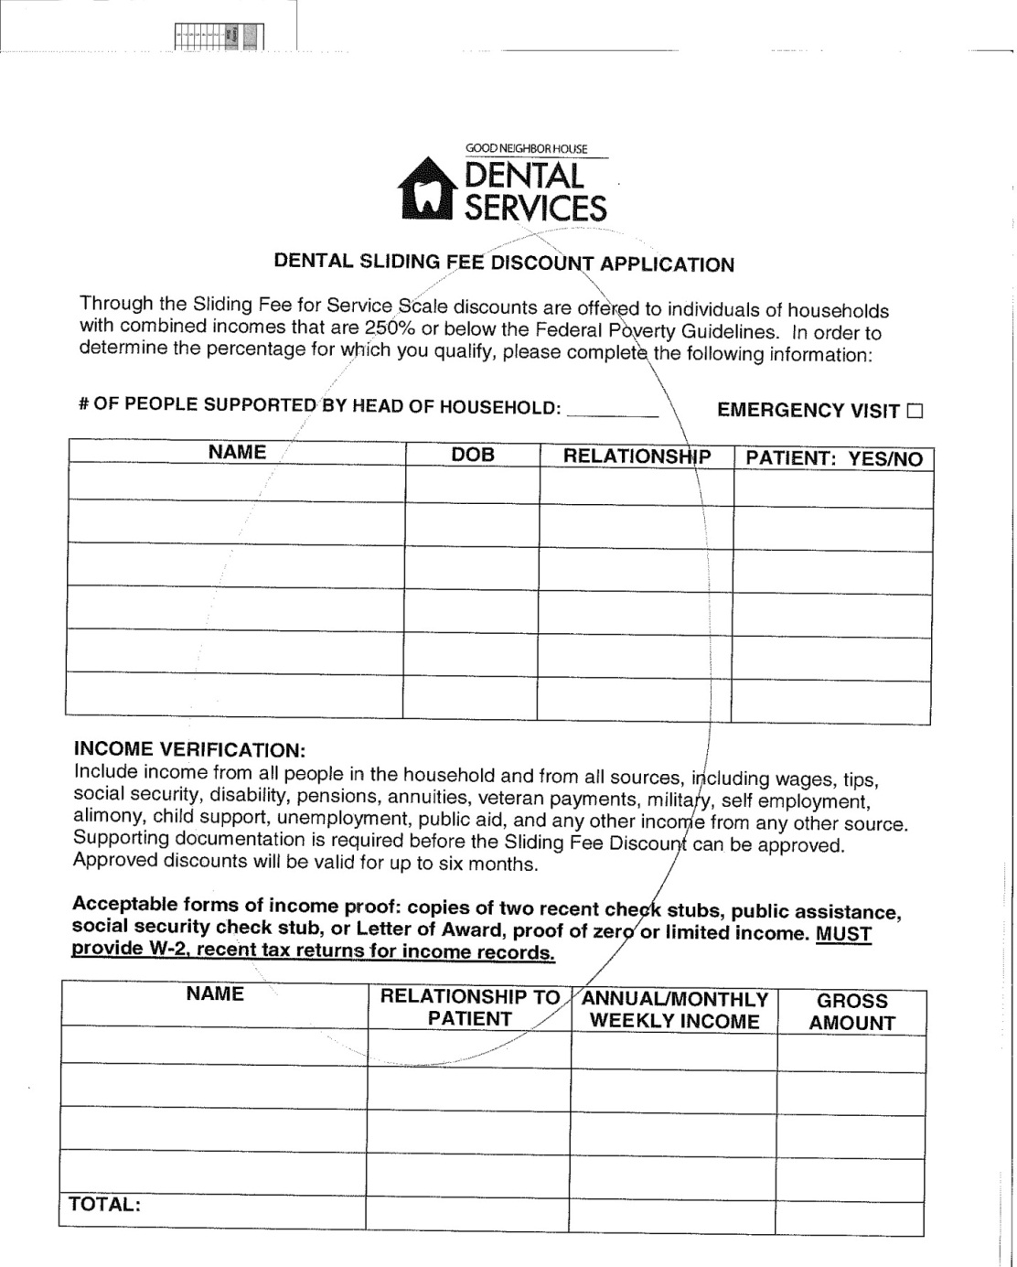

TheExhibit Fis the dental sliding fee discount application. It is used for sliding fee for service scale discounts of patients who are in households with combined income that are 250% or below the federal poverty guideline. The form contains different field such as name, date of birth, relationship, annual/monthly income and gross amount.

## Appendix G: Dental Sliding Fee Discount Application

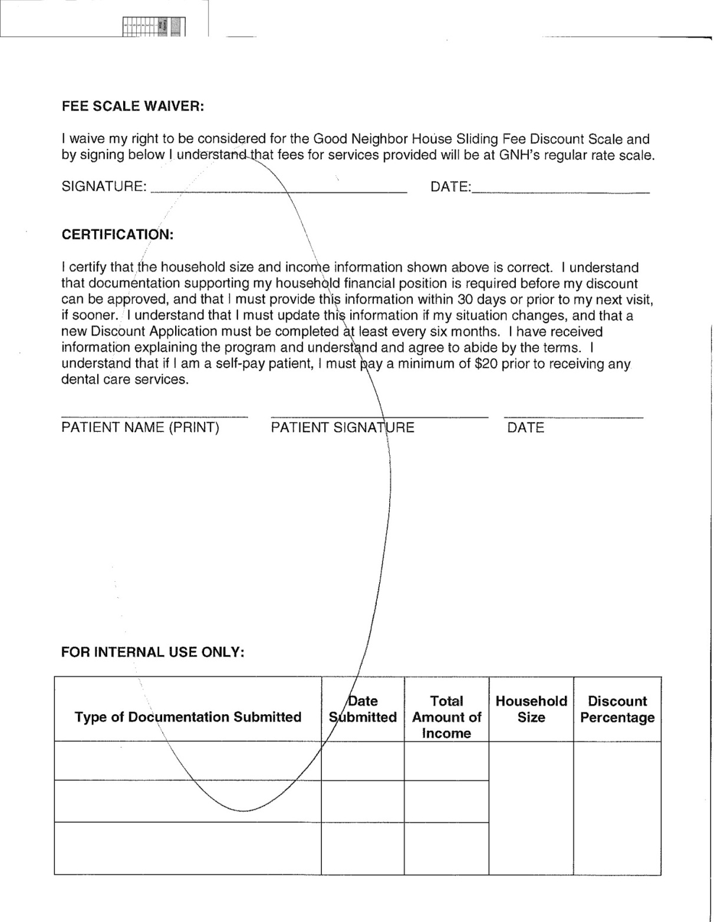

The Exhibit G is second page of dental sliding fee discount application form; which is certified by the patient that above information are correct.

## Appendix H: Health Link Information Exchange (HIEx) User Manual

Administrator

User Login Page

Enter Username and Password

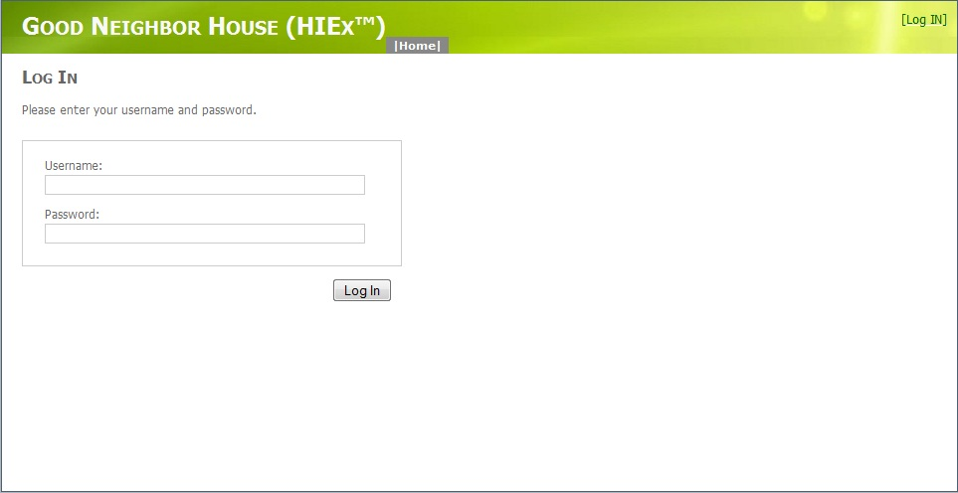

**New Password**

Administrator-> Change password

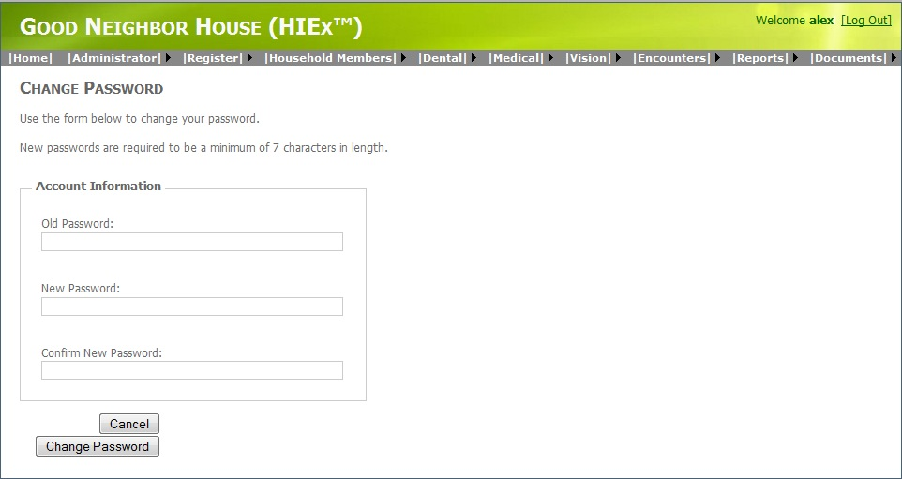

**Register New User Account**

Administrator-> Register Users

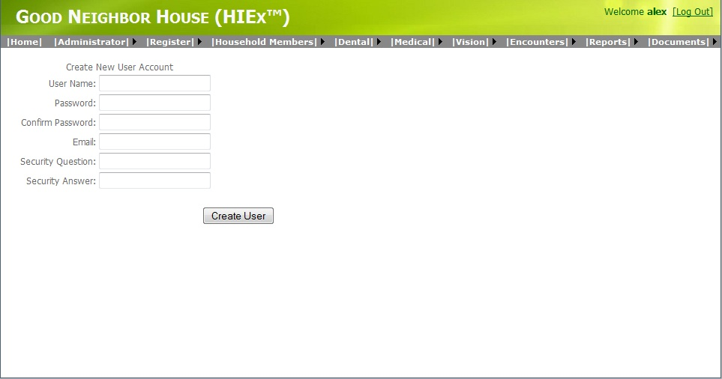

**Update Fee Scale**

Administrator-> Update Fee Scale (click edit)

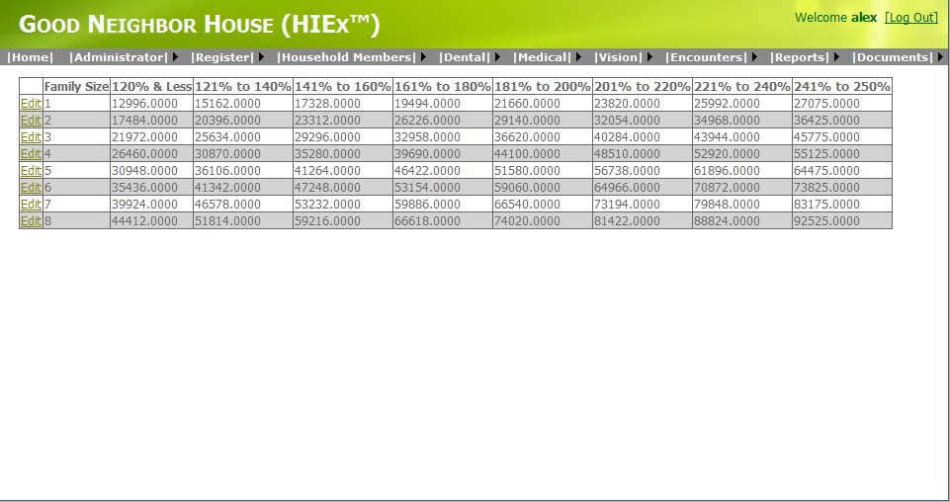

**Dental Services**

Administrator->Dental Services (click edit)

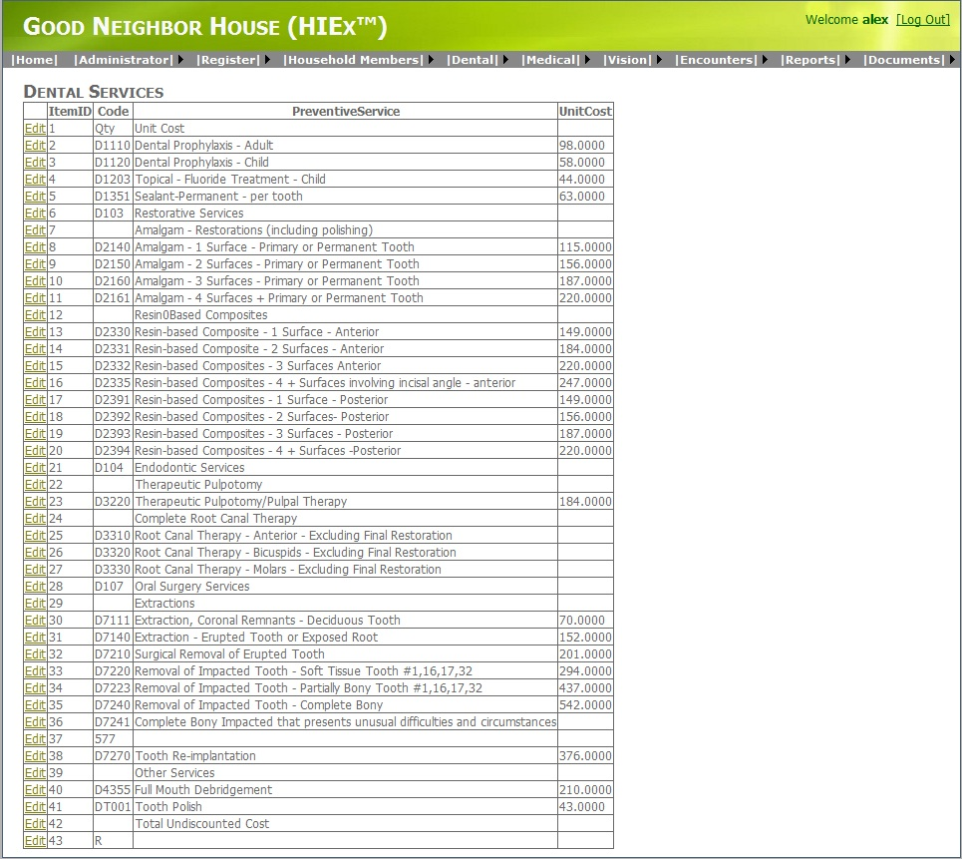

**User Activity**

Administrator-> User Activity

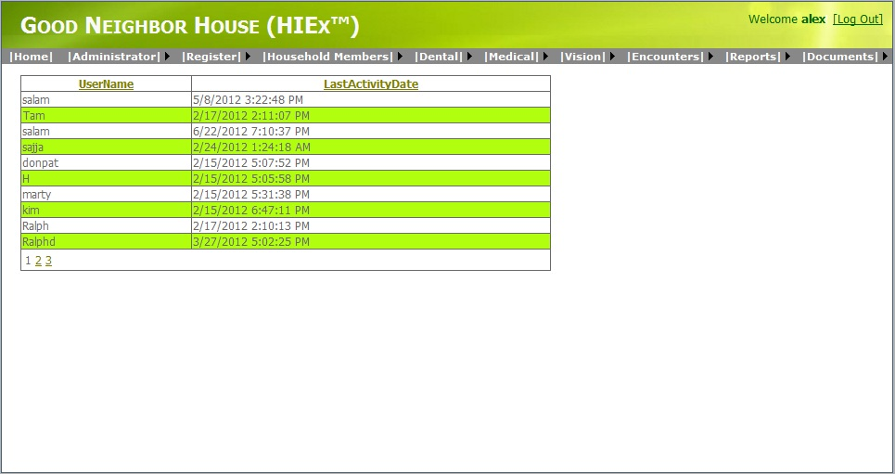

**Patient Registration**

Register->Register Patients(Click New Household) 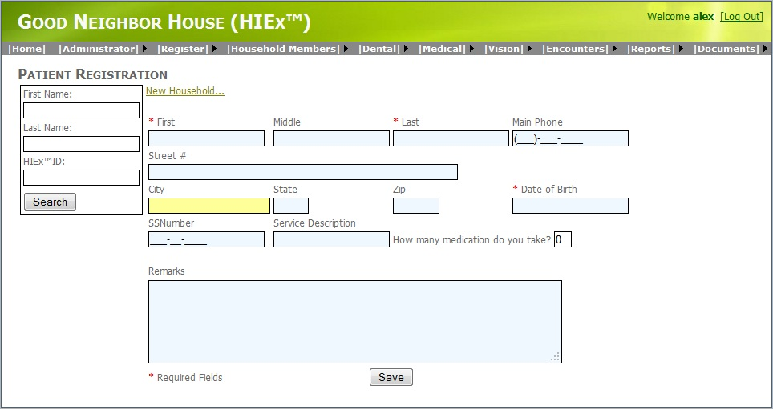

**Household members**

Household members-> Household members

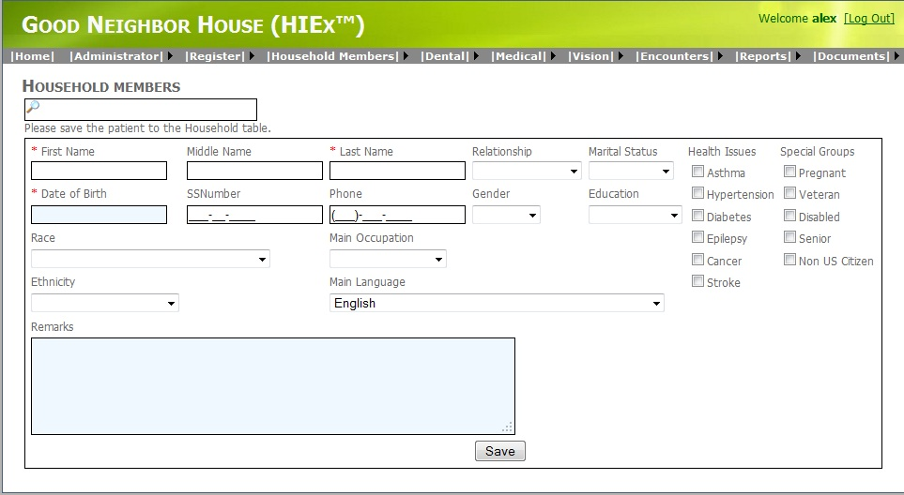

**Household Income**

Household members-> Household Income

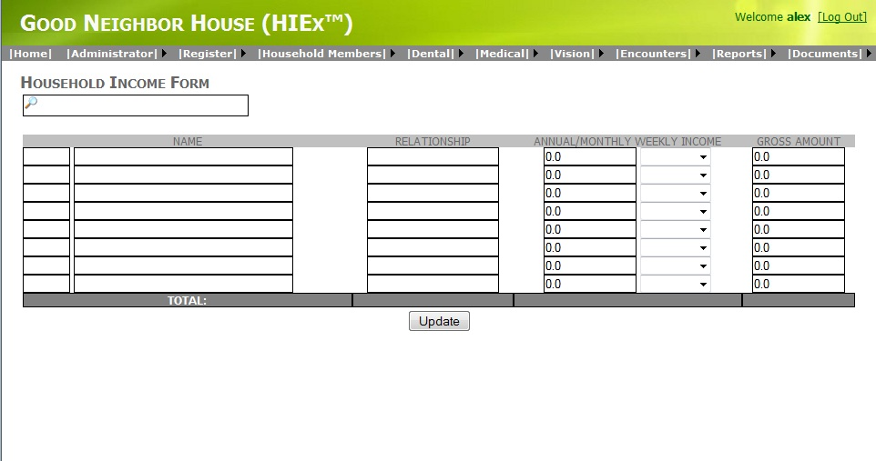

**Dental Search Form**

Dental->Search Form (enter name and click Proceed)

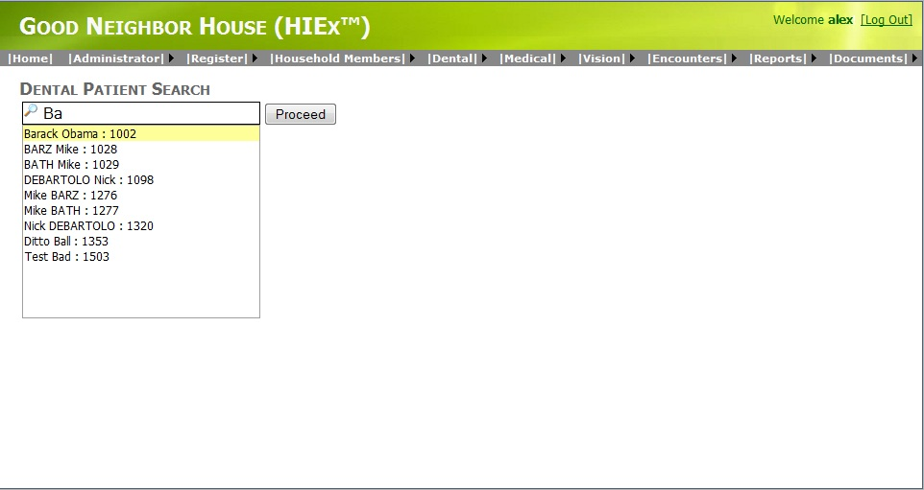

**Dentist Notes**

Dental->Dentist Notes

Click on teeth and enter dentist note and Service code then save

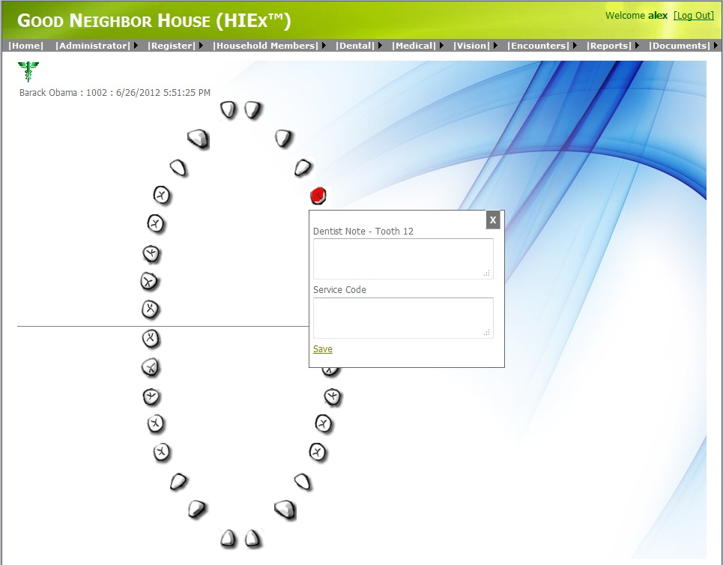

Dental Treatment Plans

Dental-> Dental Treatment Plans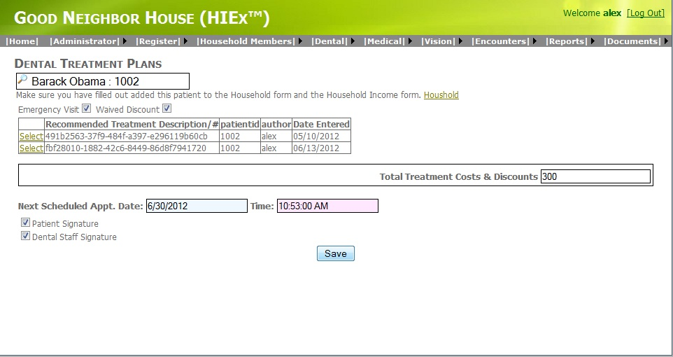

Patient Appointment

Dental-> Patient Appointment

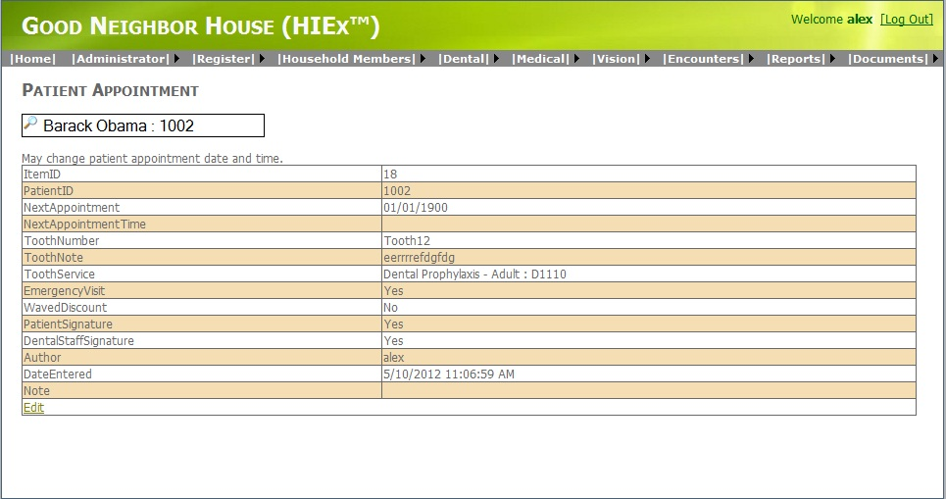

Medical Search Form

Medical->Search Form (enter name and click Proceed)

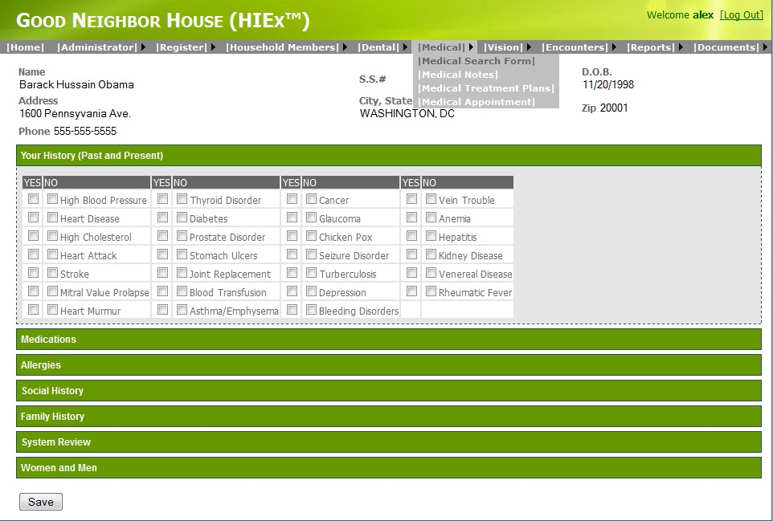

Medical Notes

Medical->Medical Notes (Enter doctor note and Service code then save)

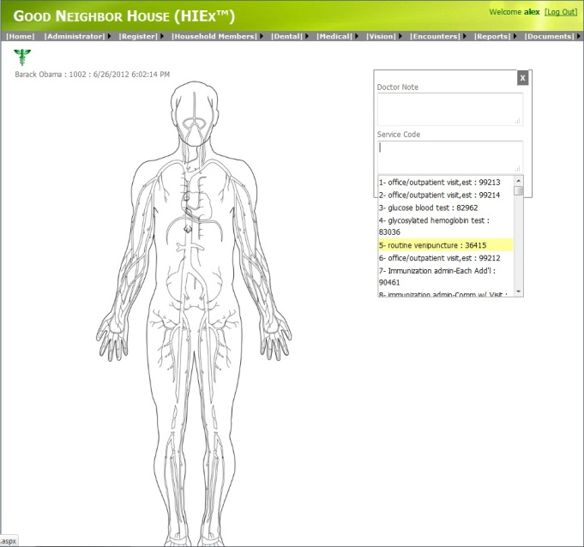

Medical Treatment Plans

Medical-> Medical Treatment Plans

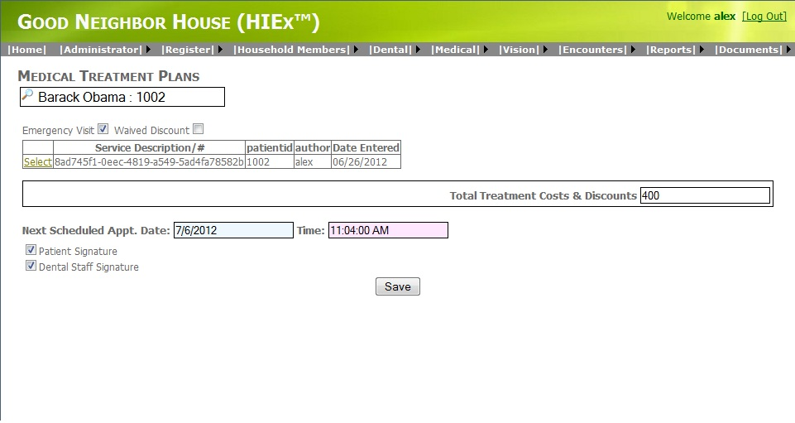

Patient Appointment

Medical-> Patient Appointment

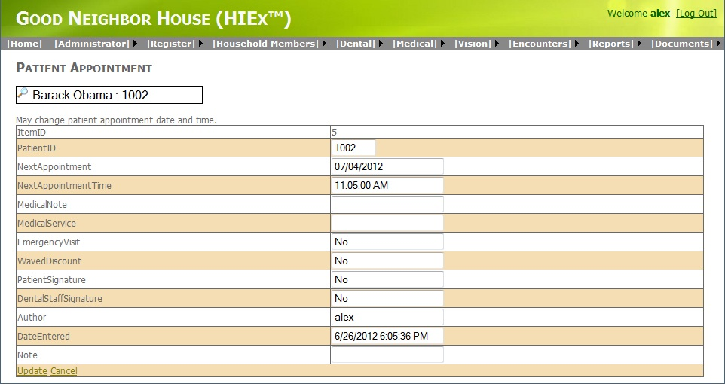

Encounters

Encounters-> Encounters

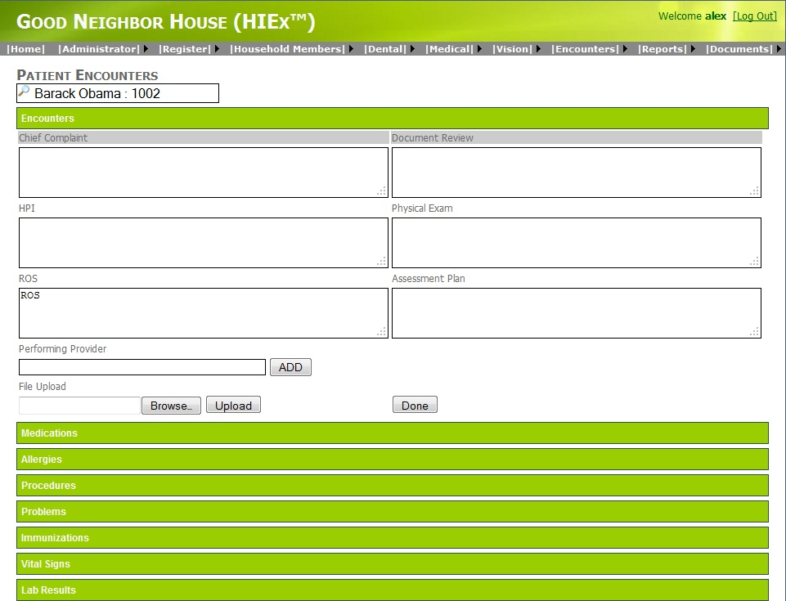

Encounters Summary

Encounters-> Encounters summary

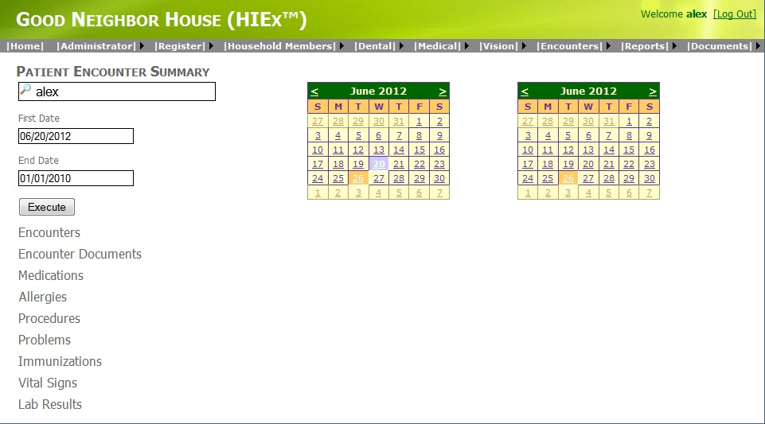

Reports Patients

Reports-> Reports Patients

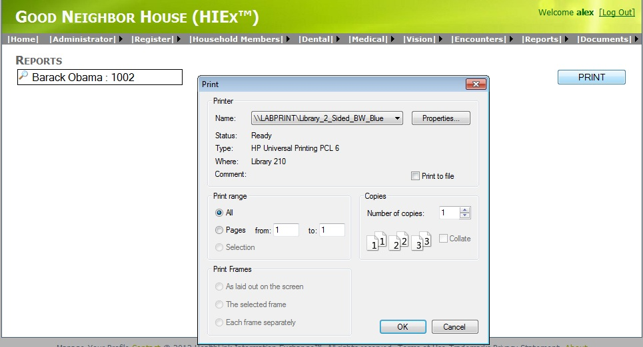

Reports Onsite

Reports -> Reports Onsite

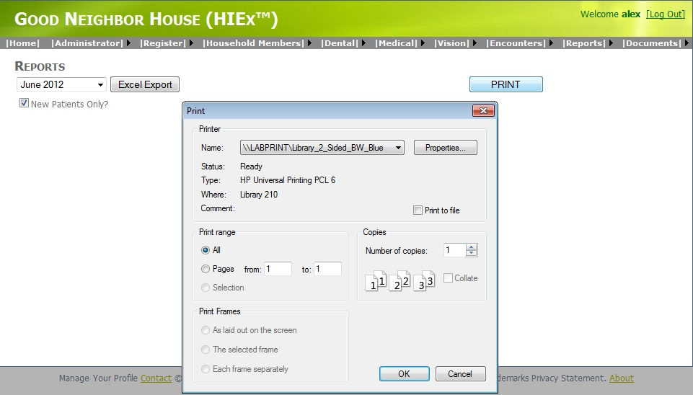

Generate CCD

Reports -> Generate CCD

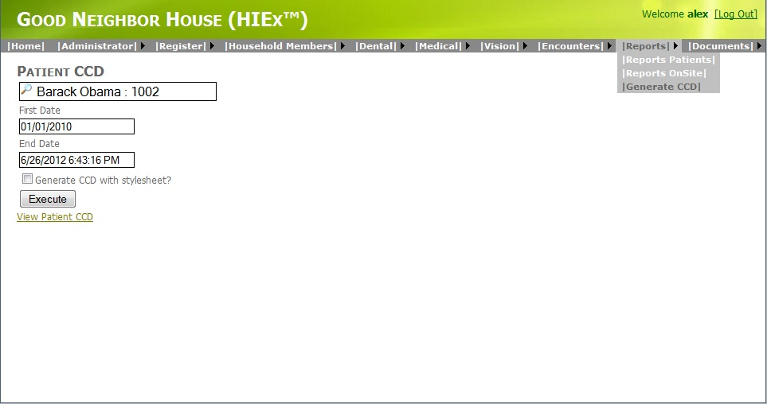

**File Upload**

Documents->File Upload

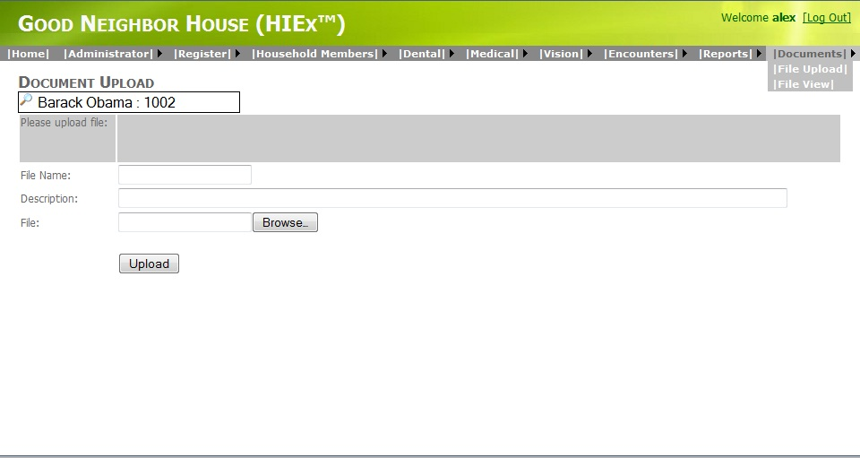

**File View**

Documents->File View

